Locating Hybrid Power Flow Controller in a 30-Bus System Using Chaotic Evolutionary Algorithm to Improve Power System Stability

Dr.B.Gopinath,M.E.,Ph.D.,

Associate Professor/Dept of EEE

Vivekanandha College of Engineering for Women

Elayampalayam,Tiruchengode

[gopivce@gmail.com](mailto:gopivce@gmail.com)

M.Pradeepa

PG student, Dept of EEE

M.Kalyanasundaram,M.E.,(Ph.D)

Assistant professor, Dept of EEE

Vivekanandha College of Engineering for Women

Elayampalayam,Tiruchengode

[mkalyanasundharam79@gmail.com](mailto:mkalyanasundharam79@gmail.com)

V.Karthika

PG Student,Dept of EEE

Vivekanandha College of Engineering for Women Vivekanandha college of Engineering for Women

Elayampalayam,Tiruchengode Elayampalayam,Tiruchengode

mpradee.226@gmail.com [karthimepse@gmail.com](mailto:karthimepse@gmail.com)

*Abstract*— **The Hybrid Power Flow Controller (HPFC) is a versatile FACTS device which can independently control the power losses and voltage stability. The main purpose of my work is to identify the optimal location and sizing of Hybrid Power Flow Controller (HPFC) by using Chaotic Evolutionary Algorithm and it is implemented inaIEEE-30 Bus systems for analyses. The algorithm employs logistic map and tent map as two chaotic systems to generate chaotic value. By this type of selection process location of required bus have been identified easily. This Algorithm technique used in phase-I it is very fast and contains lower number of iterations. To show the validity of the proposed techniques and for comparison purposes, simulations are carried out by MATLAB on IEEE-30 bus power system.**

**Keywords—*HPFC,CEA ,IEEE 30 bus system***

# I. Introduction

Economic and operational factors make power systems to utilize maximum percentage of their transmission capacity and consequently operate close to the stability limit with fewer margins. Existence of transmission system constraints dictates a finite amount of power that can be transferred between two points on the electric grid. In practice, it may not be possible to deliver the all bilateral and multilateral contracts in full and to supply all pool demand at low cost as it leads to violation of operating constraints such as voltage limits and line overloads [2]. In such stressful and tensional environment, power system congestion and voltage instability can be emerged as major threats that the system operators (SOs) may be faced with them. The SO should ensure the operation of transmission system within acceptable operating limits. Voltage security is a limiting factor in the planning and operation of many power systems. With increased system loading and a open transmission access pressures, power systems are more vulnerable to voltage instability. In a deregulated electricity market, it may always not have been possible to dispatch all of the contracted power transactions due to congestion of the transmission corridors. System operators try to manage congestion, which otherwise increases the cost of the electricity and threatens the system security and stability. Generation pattern is one of the major reasons which results in heavy flows tend to greater losses, and to threaten stability and security, ultimately making certain generation patterns economically undesirable

These problems are avoided by installing the Flexible AC Transmission Systems (FACTS) devices such as series and combined series-shunt controllers. Flexible AC Transmission System (FACTS) controllers are used increasingly to provide voltage and power flow control in many utilities. These devices used to control the power flows in the network, can help to reduce the flows in heavily loaded lines, the resulting in increased load ability, low system loss, improved stability of the network, reduced cost of production and fulfilled contractual requirement. A possibility of controlling power flow in the electric power system without generation rescheduling or topological changes can improve the performance considerably. It is important to ascertain the location for placement of these devices because of their considerable costs.

The proposed topology of HPFC consists of a shunt connected controllable source of reactive power, and two series connected voltage–sourced converters and one on each side of the shunt device. The two converters can exchange active power through a common DC circuit. By controlling the magnitudes and the angles of voltage vectors injected by the converters, the ﬂow of active power through the line and the amounts of reactive power supplied to the sending and receiving segments of the line can be simultaneously and independently controlled. The control of the shunt device is coordinated with the control of the converters to provide the bulk of the total required reactive power. Since the converters are used along with the passive components the proposed topology can be considered “hybrid” and consequently, the proposed FACTS controller is named the “Hybrid Power Flow Controller” (HPFC).The main advantage of the HPFC is that it can utilize existing equipment, and hence substantial cost savings in the required converter ratings can be realized.

In this thesis, a chaotic evolutionary algorithm based is proposed to determine the suitable number and size of HPFC and also its optimal location in power systems for improving the voltage security and active power loss reduction. Hence, a number of HPFC are allocated at particular buses and lines in order to improve the voltage security margin and active power loss reduction. The investment cost of this kind of FACTS devices is also considered in this paper study. The optimization is carried out on the basis of location, size and number of UPFC using CEA.

**II. Static Model of HPFC**

Let the circuit losses be neglected:

$R_{S}=R_{R}=0$ (1)

To generalize the discussion with respect to the point of equipment installation, let XL and k be deﬁned as:

$X_{L}=X_{S}+X_{R}$ (2) $K=\frac{X_{S}}{X_{L}}$ (3)

Next, let the following phasors be introduced:

$V_{S}=V_{S}∠δ$ (4)

$V_{R}=V_{R}∠0$ (5)

$V_{X}=V_{X}∠δ_{X}$ (6) 6

$V_{Y}=V_{Y}∠δ_{Y}$ (7) 7

The steady state phasor equations of the AC portion of the circuit are:

$jkX_{L}I_{S}+\frac{1}{{jB}_{M}}\left(I_{S}-I_{R}\right)=V_{S}-V_{X}-\frac{1}{{jB}_{M}}\left(I_{S}-I_{R}\right)+j\left(1-k\right)X_{L}I_{R}=-V_{R}+V_{Y}$ (8) 8

To maintain ﬁxed charge on CDC, i.e., a steady state condition, the converters represented by voltage sources VX, and VY have to operate under the “constraint of power balance”:

$Re\left[V_{X}I_{S}^{*}\right]=Re\left[V_{Y}I_{R}^{*}\right]$ (9) 9

There are several limit conditions that should be imposed on the operation of the circuit.First, there are limits due to the practical converter sizes:

$\sqrt{2}\left|V_{X}\right|≤V_{X_{max}}$ (10) 10

$\sqrt{2}\left|I_{S}\right|≤I_{X_{max}}$ (11) 11

$\sqrt{2}\left|V_{Y}\right|≤V_{Y_{max}}$ (12) 12

$\sqrt{2}\left|I_{R}\right|≤I_{Y_{max}}$ (13) 13

Then, voltages at the equipment terminals are to be limited due to the insulation requirements:

$\sqrt{2}\left|V_{1}\right|≤V_{1_{max}}$ (14) 14

$\sqrt{2}\left|V_{2}\right|≤V_{2_{max}}$ (15) 15

Lower limits of terminal voltages may also be speciﬁed. These limits were not considered in the thesis, nevertheless, the analysis methodology used in the thesis can be easily adapted to include such additional requirements.

Finally the voltage ratings used for the shunt susceptance will stipulate that

$\sqrt{2}\left|V_{M}\right|≤V_{M_{max}}$ (16) 16

The phasor diagram representing one operating point of the line controlled by the HPFC is shown in Figure 1. The operating point represents a power ﬂow lower than the “naturally occurring” power ﬂow. Namely, if the two regions were directly interconnected, the “natural”power transfer between VS and VR

$P_{O}=3\frac{\left|V_{S}\right|\left|V_{R}\right|}{X_{L}}\sin\left(δ\right)$ (17)

where δ represents the angle between the two voltages, as marked in Figure 1. The power ﬂow controller changes this naturally occurring power transfer. In the case of the operating point shown in Figure 2 reduction of power ﬂow is achieved by injecting voltages VX and VY to reduce the angular diﬀerences between VS and V1, and V2 and VR, respectively

The viable operating points could be obtained using iterative numerical techniques. A traditional approach is to express the desired output quantities (i.e., P2, Q1, and Q2) and variables subject to constraints (i.e., PX −PY, IS, IR, |V1|, |V2|, and |VM|) as functions of control variables (VX, δX, VY, δY, BM); and then, to use numerical iterations to achieve the desired solution. It can be observed that ﬁve control variables are at disposal to solve a system of four nonlinear equations, (i.e., P2 = P2ref, Q1 = Q1ref, Q2 = Q2ref, and PX −PY = 0). The existence of an additional degree of freedom gives rise to a notion of optimization, and qualiﬁes the problem of selecting viable operating points into the class of problems of nonlinear constrained optimization.

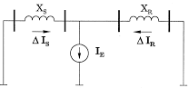

Fig.1.Equivalent circuit of HPFC

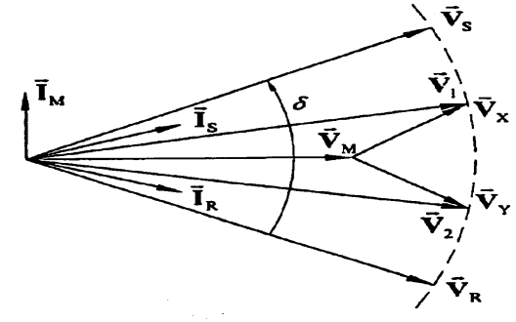

Fig.2. Phasor Diagram of HPFC

**III. Overview of CEA and its implemenation for Optimal Solution of Problem**

Chaos is a bounded dynamic behavior that it occurs in deterministic nonlinear system. Although, it appears to be stochastic, it occurs in a deterministic nonlinear system under deterministic conditions. It is highly sensitive to changes of initial condition than a small change to initial condition can lead to a big change in the behavior of the system. Chaos theory is typically described as the so-called ‘butterfly effect’ detailed by Lorenz in 1963. There are three main properties of the chaotic map, i.e.

* Ergodicity
* Randomness.
* Sensitivity to initial condition

Ergodicity property of chaos can ensure chaotic variables to traverse all state non-repeatedly within a certain range according to its own laws . So, this is can be used as an optimization mechanism which avoids falling into local minimum solution. The sensibility to the initial state, one of the most important characters of chaotic systems, can ensure that there are not two identical new populations even if the two best fit solutions obtained by sequential evolving procedures are very close. So, such population not only reserves the best fit chromosome, but also maintains population diversity.

By using these properties, an effective approach was proposed for maintaining the population diversity and avoids the search being trapped in local optimum. In this paper, we use logistic and tent maps to generate the chaotic sequence. Chaotic sequences have been proven easy and fast to generate and store, there is no need for storage of long sequences. In addition, an enormous number of different sequences can be generated simply by changing its initial condition. Moreover, these sequences are deterministic and reproducible. We outline the two chaotic mappings as follows:

1. Logistic Map: Is one of the simplest forms of chaotic mappings. Basically, this map is a polynomial mapping of degree 2, whose equation is the following:

$X_{n+1}=γX_{n}\left(1-X_{n}\right)X_{n}ϵ(0,1)$ (4.1)

Where, *r* is a control parameter which is between 0 and 4. Obviously, *Xϵ* (*0*, *1*) under the conditions that the initial *X0ϵ* (*0*, *1*) and that *X0ϵ* {*0.0*, *0.25*,*0.75*, *0.5*, *1.0*}. When *3.57< r≤ 4*, the system has proven to be chaotic state. In this paper, *r=4* is used. Figure 1-b shows its chaotic dynamics, where, $X_{0}$*=0.4*.

1. Tent Map : Is one of the known chaotic systems and it is a discrete-time dynamical system, whose equation is the following:

$x_{n+1}=\left\{\begin{aligned}μx_{n}x_{n}<\frac{1}{2} \\ μ\left(1-x_{n}\right)x_{n}<\frac{1}{2}\end{aligned}\right.$ (4.2)

Where, *µ* is a control parameter, when *1< µ< 2*, the system exhibits chaotic behaviour. In this thesis, we take *µ=1.5*. Figure 1-a shows its chaotic dynamics, where, $x_{0}$*=0.3*.

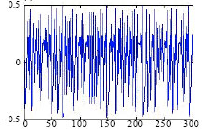

Fig.3.Dynamics of tent map.

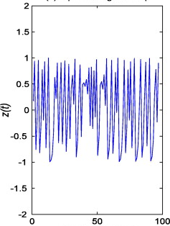

Fig.4.Dynamics of logistic map.

A) Chaos Genetic Algorithm Procedure

Recently, chaos theory and the generation of chaotic sequences instead of random ones have been adopted, which has led to very interesting results in many applications such as optimization of power flow problems, control systems, neural networks, cryptography and image processing and others. Due to the easy implementation and special ability to avoid being trapped in local optima, chaos has been a novel optimization technique and chaos based search algorithms have aroused intense interests. Many researchers have found a close-knit relationship between chaos and cryptography and many of their properties can be found in traditional cryptosystems. Abdullah et. al[16] introduced a hybrid method based on GA and chaotic function for image encryption; their results show that the hybrid method can perform a high level of resistance against statistical invasions. In random-based optimization algorithms, are used chaotic variables instead of random variables. Experimental studies assert that the benefits of using chaotic signals instead of random signals are often evident although, it is not mathematically proved yet. GA has aroused intense interest, due to the flexibility, versatility and robustness in solving optimization problems, which conventional optimization methods find difficult [17]. One of the major disadvantages of the GA is its premature convergence, especially while optimization problems have more local optima. In this situation, the solving procedure is trapped in the local optimum and most of the operators can’t produce offspring surpassing their parents any more. In this paper, CGA is proposed that combine the concept of chaos with GA.

The chaos as it was cited in pervious section is a general phenomenon is nonlinear system that has some properties such as randomness, ergodicity; regularity and sensitivity to initial condition. By use of these properties of chaos, we propose CGA based on two kinds of chaotic mapping. In improving the algorithm, we use chaotic mapping instead of random process.The standard GA uses random sequences in the initial population, crossover and mutation.

In the GA method, the initial population generated by a random approach might be unevenly distributed and away from the optimal solution. Hence, the algorithmic efficiency can be very low and more number of iteration is needed to find the global optimum. Therefore, we use the uniform distribution of the tent map to generate the initial population. Then, we use logistic map output instead of crossover and mutation each time a random number is needed. The flowchart of the proposed method has been shown in Figure 5.

B) Algorithm

Step:1 Start the iteration process

Step:2 First use the tent map to generate the initial population as assign as the required parameters

Step:3 Calculate required fitness for the individuals for a required parameters

Step:4 The overall evolution process is done in this process

Step:5 After the evolution process if its satisfied all the conditions stop the iteration.If it was not satisfied again it starts from step:3

Use Tent Map to Generate the Initial Population Populations

Calculate Fitness for Individuals

selection

mutation

Crossover

Logistic Map

Is terminate condition is satisfied?

No

Yes

Fig 5.CEA flowchart

**VI. Simulation Result**

A)Optimal Location of HPFC –Chaotic Evolutionary algorithm

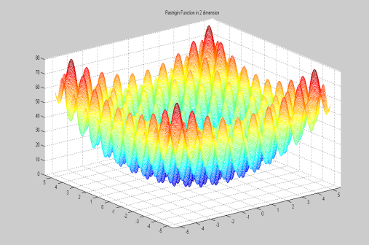

Fig.6.Stability Analysis Graph

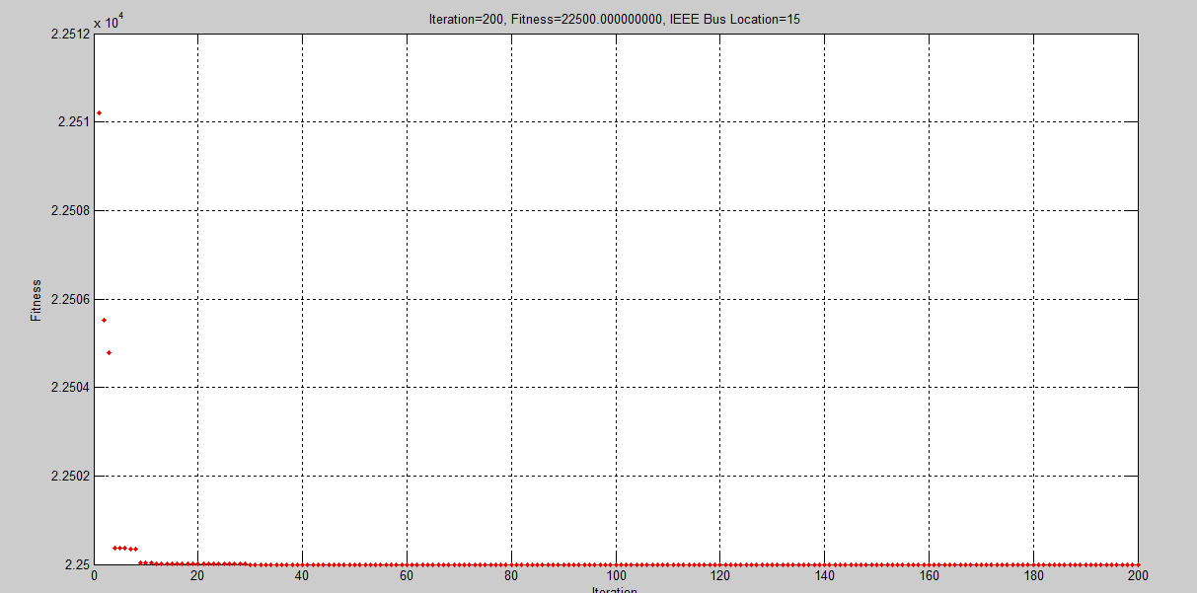

Fig.7.Iteration and fitness of CEA

From the simulation at Figure 6 and Figure7obtain an optimal location of HPFC. By comparing all those buses in a systems to find the best location were the power losses and voltage collapse have been reduced in the Figure 4.1a thus it helps to improve power system stability. The Figure 4.1b shows at the 200th iteration the location of the bus system is obtained and their fitness is 22500 then its shows the best location of bus system as 15th bus from IEEE 30 bus system

B)Required Power Losses of the System

The Figure 8 shows that the power before and after implementation of the HPFC. Before implementing the device the losses of the system is in increased manner. After the device implementation in the bus system have regulate the overall system. The losses of the system is reduced. Here the output is obtain with respect to time

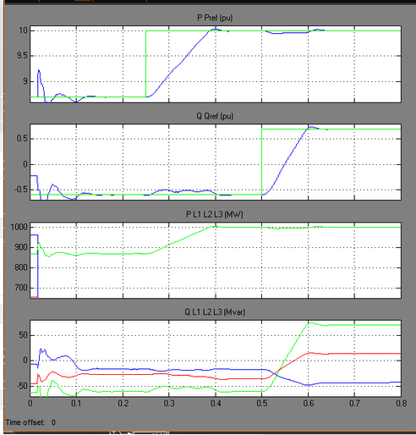

Fig.8. Power Output

C)Regulated Voltage and Current

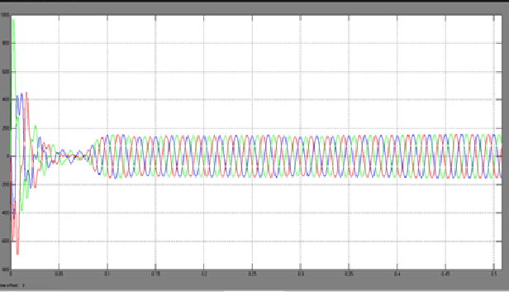

Fig.9.Voltage Waveform

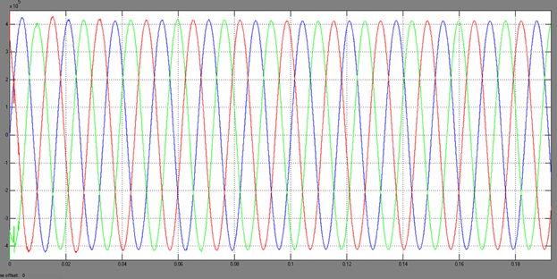

Fig.10. Current Waveform

These Figures shows the regulated voltage and current with the fewer amounts of losses. At the Figure 9 the voltage collapse was make the systems unstable at the required place the HPFC was implemented and maintains the losses.

**V.Conclusion**

The proposed technique was implemented in the MATLAB platform. It was used to find the optimal location and the power rating of the HPFC based on the voltage and the minimum power losses. The CEA technique was investigated to improve the stability of transmission system by reducing voltage collapse and power losses. The proposed technique was tested with the IEEE 30 bus system. Initially the power losses of the system was analysed and determine the optimal location of HPFC. From the 30 buses the 15th bus location is selected in proposed work because this location is used to control maximum number of buses. Then the HPFC is placed on the location and the stability of the system was analysed. Subsequently, the power losses and the injected voltage were analysed and their results was discussed.

**References**

1. [EsmaeilGhahremani](http://ieeexplore.ieee.org/search/searchresult.jsp?searchWithin=%22Authors%22:.QT.Esmaeil%20Ghahremani.QT.&newsearch=true)&[Innocent Kamwa](http://ieeexplore.ieee.org/search/searchresult.jsp?searchWithin=%22Authors%22:.QT.Innocent%20Kamwa.QT.&newsearch=true),2013, ‘Optimal placement of multiple-type FACTS devices to maximize power system loadability using a generic graphical user interface’,[IEEE Transactions on Power Systems](http://ieeexplore.ieee.org/xpl/RecentIssue.jsp?punumber=59),Vol. 28,Issue.2,pp.66-98.
2. Sai Ram Inkollu&Venkata Reddy Kota,2016, ‘Optimal setting of FACTS devices for voltage stability improvement using PSO adaptive GSA hybrid algorithm’, in Engineering Science and Technology an International Journal,pp.1166–1176.
3. Sreerama Kumar R.,IbrahimJomoah, &Abdullah Omar Bafail,2014, ‘Optimal Placement of Unified Power Flow Controller forMinimization of Power Transmission Line Losses’, International Journal of Computer Theory and Engineering, Vol. 6,pp.87-98.
4. Harshavardhan Reddy &Padma Lalitha,2014, ‘Enhancement of Voltage Stability by optimal location of UPFC using MPSO and Power Flow Analysis using ECI Algorithm’, IOSR-JEEE, Vol. 9,pp. 41-47.
5. Vanitha R.&Sudhakaran M.,2011, ‘Optimal Location and Control Parameter Settings of UPFC using Differential Evolution Algorithm’, International Journal of Computer Applications, Volume.31,pp.368-377.
6. PinkiYadav,SharmaP.R.&Gupta S.K.,2015, ‘Bat Search Algorithm Based Hybrid PSO Approaches to Optimize the Location of UPFC in Power System’, International Journal on Electrical Engineering and Informatics,Vol.7, No.3.
7. Islam YoucefDjilaniKobibi, Samir Hadjeri,&Mohammed AbdeldjalilDjehaf,2016, ‘Study of UPFC Optimal Location Considering Loss Reduction and Improvement of Voltage Stability and Power Flow’, International Journal on Electrical Engineering and Informatics, Vol. 5, pp.2321-8169.
8. Ramesh P. &Damodara Reddy M.,2016, ‘Optimal Placement Of Distributed Power-Flow Controller For Loss Reduction Using Firefly And Genetic Algorithm’ ,IJRET, pp.2321-7308.
9. OmidZiaee&Fred Choobineh F.,2014, ‘Thyristor-Controlled Switch Capacitor Placement in Large-Scale PowerSystems via Mixed Integer Linear Programming and Taylor Series Expansion’, Exposition IEEE, pp.693-977.
10. LashkarAra A. &Kazemi A.,2012, ‘Multiobjective Optimal Location of FACTS Shunt-Series Controllers for Power System Operation Planning’,IEEETransactions On Power Delivery, Vol. 27, No. 2.
11. Maheswararao D. &Raja Gopal K., 2015, ‘A Noval Method Of Voltage Control For Power Flow Management By Usingadvaned Facts Devices’, International Journal of New Technologies in Science and Engineering,Vol. 2,pp.2349-0780.
12. Amin Bakhtiari&ShahramJavadi,2016, ‘UPFC Siting and Sizing in Power Network Using Two Different Evolutionary Algorithms’,International Journal of Smart Electrical Engineering, Vol.5, No.3,pp.681-686.